TECHNICAL DATA SHEET

HALONIX TECHNOLOGIES PRIVATE LIMITED
Regd Office:-
B-31, Noida Phase – II, Dist.-Gautam Budh Nagar, U.P, Pin-201305

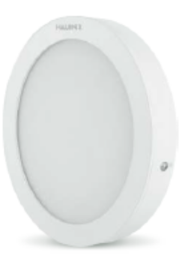

LED 15W Down Light
HLDLS- R06 -15-CW
As per IS 10322 & IEC 60598-1

Product Description: Energy efficient 15W LED Down Light

Technical Specifications:
Main Housing / Heat Sink Material: Duly powder coated Aluminium PDC
Front Cover: PMMA
LED: LM80 certified LED
Control Gear: External CC driver
Internal Wiring: Insulated Cu wire
Hardwares: SS & MS Zinc plated and passivated
Ingress Protection: IP40
Operating Voltage: 140V~270V
Operating Temperature: -10ᵒC~ 50ᵒC

GA Drawing:

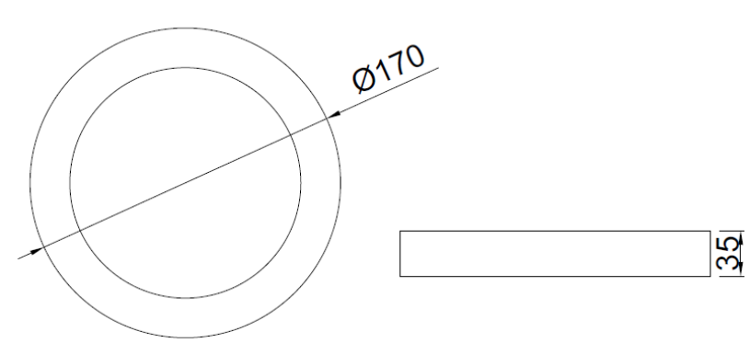

All dimensions in mm (Tolerance: ± 5mm)

Electrical & Photometry Parameters:
Rated Voltage & Frequency | System Wattage | System Current | Power Factor | System Lumen Efficacy | CCT (As per ANSI) | CRI | THD | Driver Efficiency
240V, 50Hz | 15W±10% | <72mA | >0.95 | ≥70lm/W | 6500K | ≥80 | ≤15% | ≥85%

System Protections:
Open & Short circuit protection, reverse polarity protection, surge protection of 2.5KV internal.

Application:
Offices, commercial complexes, showrooms, retail outlets, malls, reception lobbies, hotel lobbies, high roof Indoor lighting applications, etc.

Mounting:
Surface mounting.

Note: Due to continuous efforts in developing products, improvement M/s Halonix Technologies Pvt Ltd reserves the right to make changes in the design and data and withdraw the luminaries without any prior notice. | Prepared by : | MK/NK | Industrial Luminaire :
 | Checked by : | AS | Cat. Ref. : HLDLS- R06 -15-CW
 | Approved by : | RL | Document No :
As improvement in design & method of manufacturing is a continuous process, the product supplied may differ in details from above given data.

